Completed a Website by Webdesign Fundamentals

|  |  |  |  |  |  |
| --- | --- | --- | --- | --- | --- |
| Student Name: | Aomi Kosugi | Student Number: | S00217075 | Class Group: | B |

## Proposal Form

## 1. Proposed 4 Page Web Site Topic

|  |
| --- |
| [Short description of the website goals and objectives and intended audience]  Job searching website where you can search jobs and apply for it  for people who are seeking for jobs |

## 2. Proposed Design

|  |
| --- |
| [Short description of the website logo, main navigation, colors, sources of information]  Logo: **J hunt**  Color: Black  Sources of information: job titles, description, form to apply for jobs |

## 3. Proposed Design of each page content

|  |
| --- |
| [Short description of the website content of each page, colours, text font types etc and sources]  Page 1 You can search by area or job title on the first page  Page2 If you press either image 1,2,3,4 or 5 (main cities in Ireland) details of one of the cities you clicked pops up.  Page3 If you press one of the names of a place, jobs pop up.  Page4 If you click on one of the jobs, you can see the job description. |

## 4. Rough Proposed sketch of website home page -

|  |
| --- |
| [example in Chapter 18 (slide 40) can sketch by hand or use app and include photo image]   |

## Notes: Project outline

You will need to create a simple website on a topic of your choice. A proposed topic and design brief must be submitted on or before Monday 15/2/21 @9am. This proposal is worth 3% of your marks. Once your lecturer approves your design and marked on moodle, you can then start developing your site.

## Included in your Website

Your web site will include all of the following:-

* Good coding practices - Code Comments, Code Indentation, White space,
* Web pages should Clear consistent design, Visually attractive clear and clean and aligned. Suitable use of colours and fonts, all text and images referenced.(Public domain images).
* All text content must be clear concise and meaningful and reference link to source. **Do not reference any personnel details, name etc or any reference to IT Sligo on the web pages**.
* Place on the following text on the home page. *This is a college project completed as part of an assignment.*

*Project will consist of the following and you will be provided with a complete check list of features which will form the marking scheme for the project*

* Internal and external styling (CSS), minimum of 4 html pages, appropriate use of sematic HTML 5 on every page, background and foreground, tables of statistical data, internal and external links, lists numbered and bullet, video, a contact form, radio buttons etc , google map, footer on every page with Copyright notice.
* Also additions marks for addition features not outlined above. Project checklist and marking scheme will be available on Moodle.

## Proposal submission

* Word document upload on Moodle with sections 1-4 above completed. (Don’t forget your personal details)

**GitHub link** <https://aomikosugi.github.io/jhuntwebsite/>

**Completed Website Topic**

A website that people can easily search jobs from areas where they are close by called Jhunt (job hunt).

**Completed Design and description for each page**

Page1(Home)

Placed logo on the top-left, used mainly sky blue, grey as secondary, pink as accent color, a rectangle picture for good visual.

Included heading with links to other county pages, description about this website, and rough areas in Ireland, also included search bars, google map and a YouTube video as useful information and footer navigation, and put aside as a side bar.

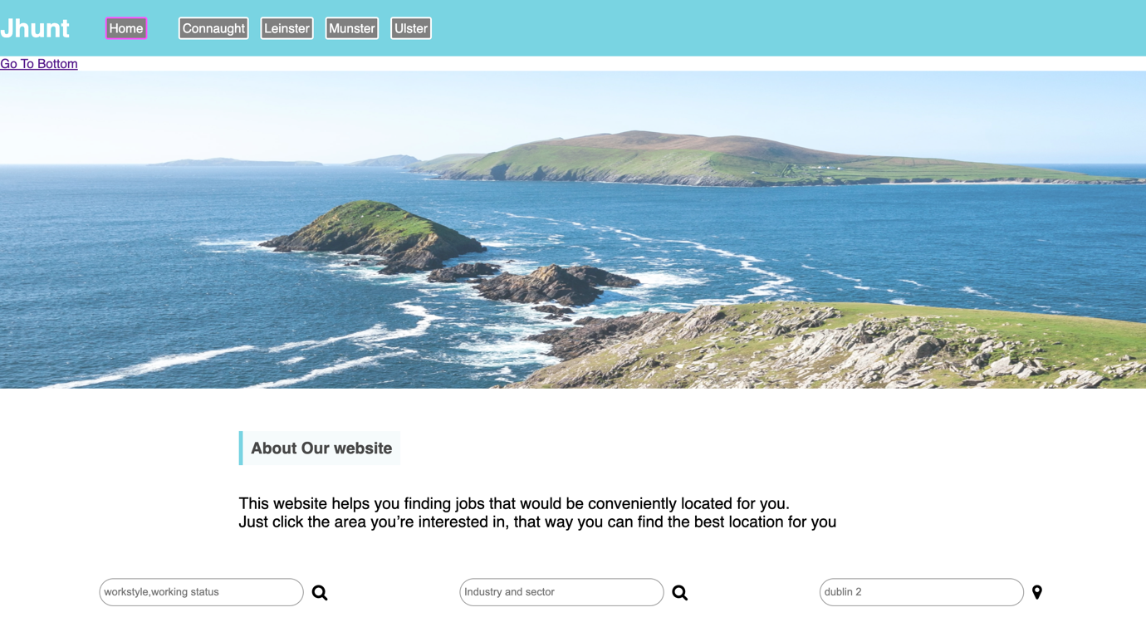

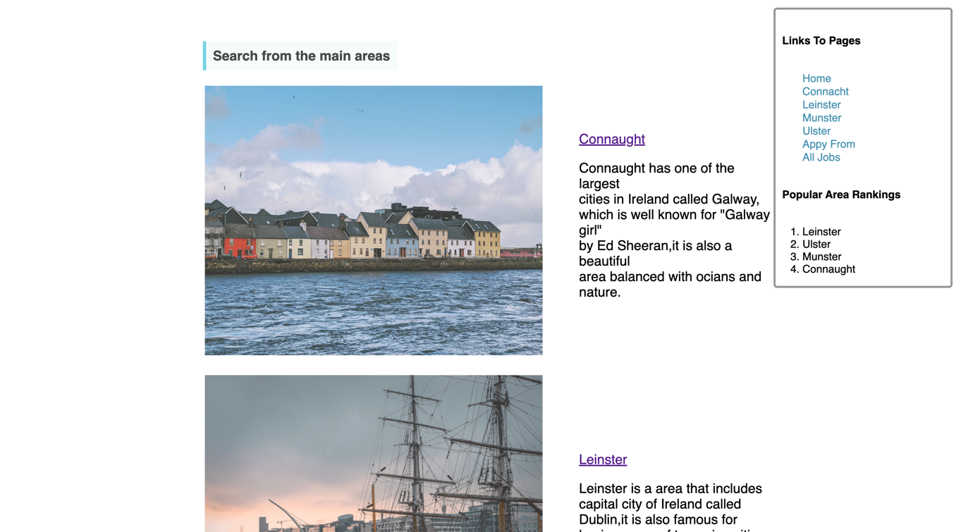

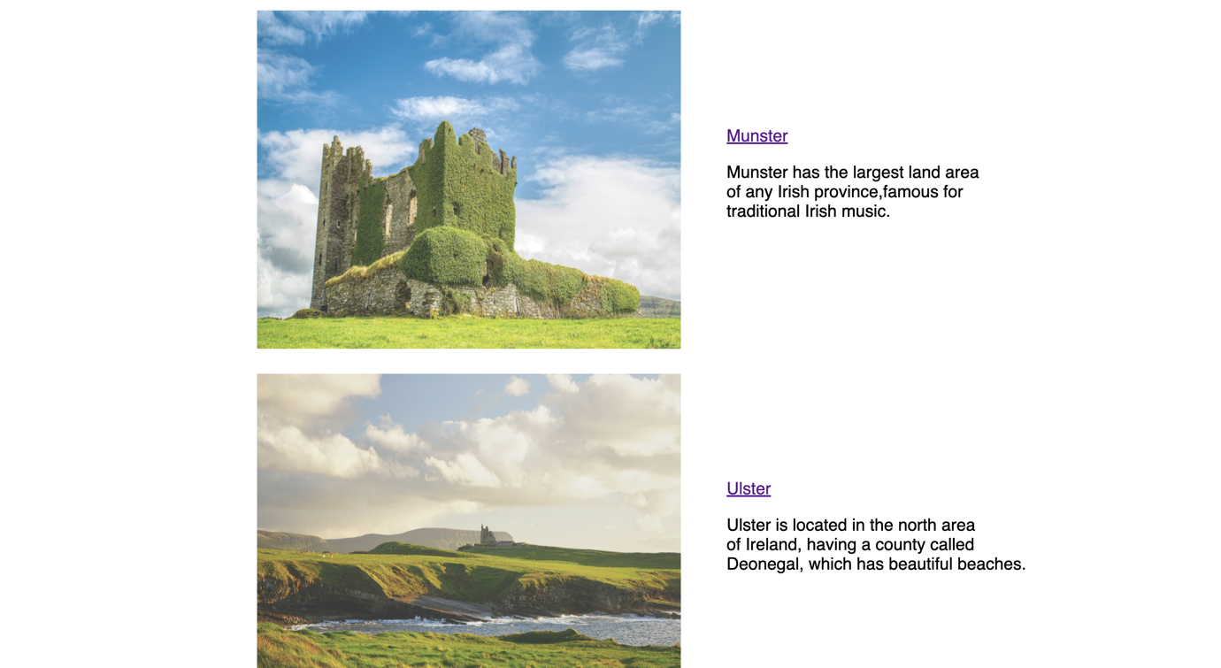

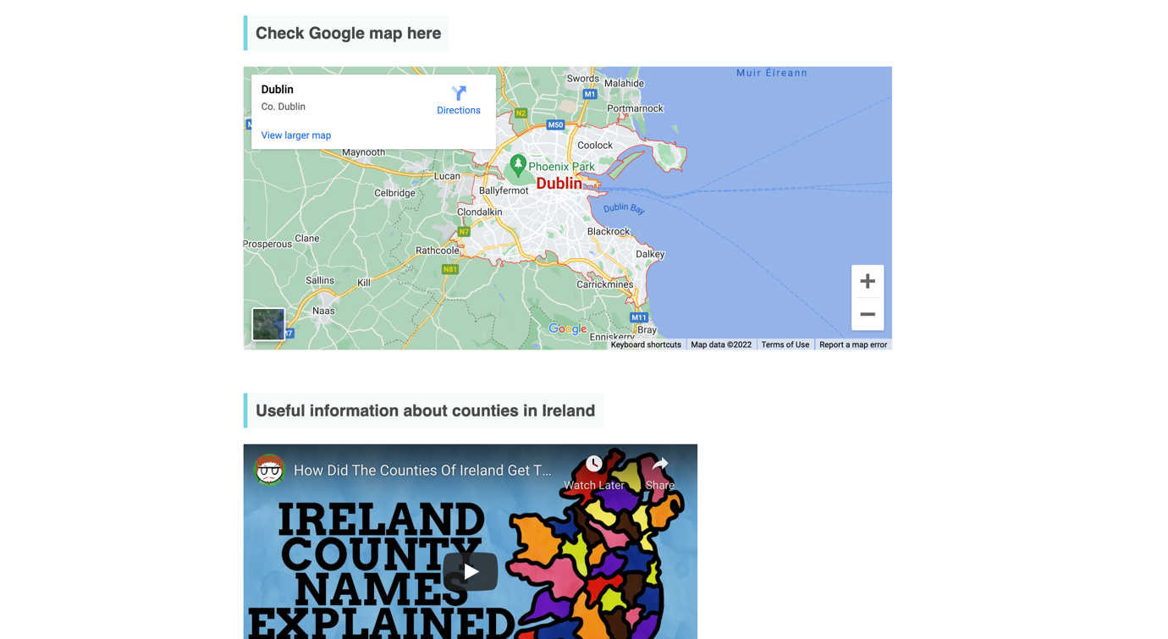

Page2(Connacht page)

I put information about Connacht with the link to Wikipedia, added background image, and links to counties of Connacht.

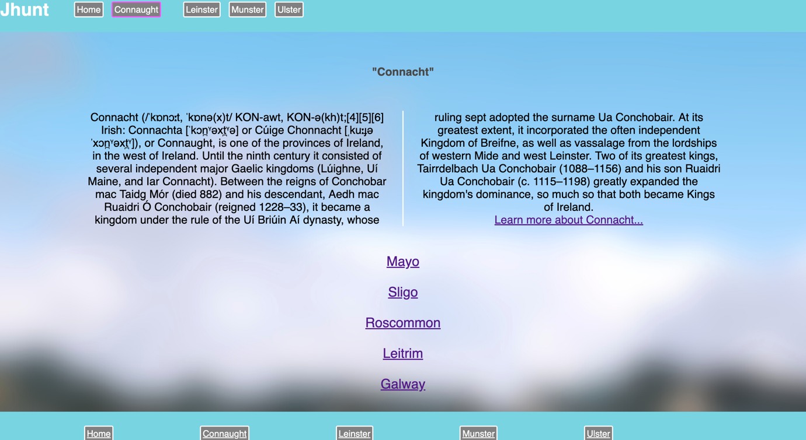

Page3(Leinster page)

I put information about Leinster with the link to Wikipedia, added background image, and links to counties of Leinster.

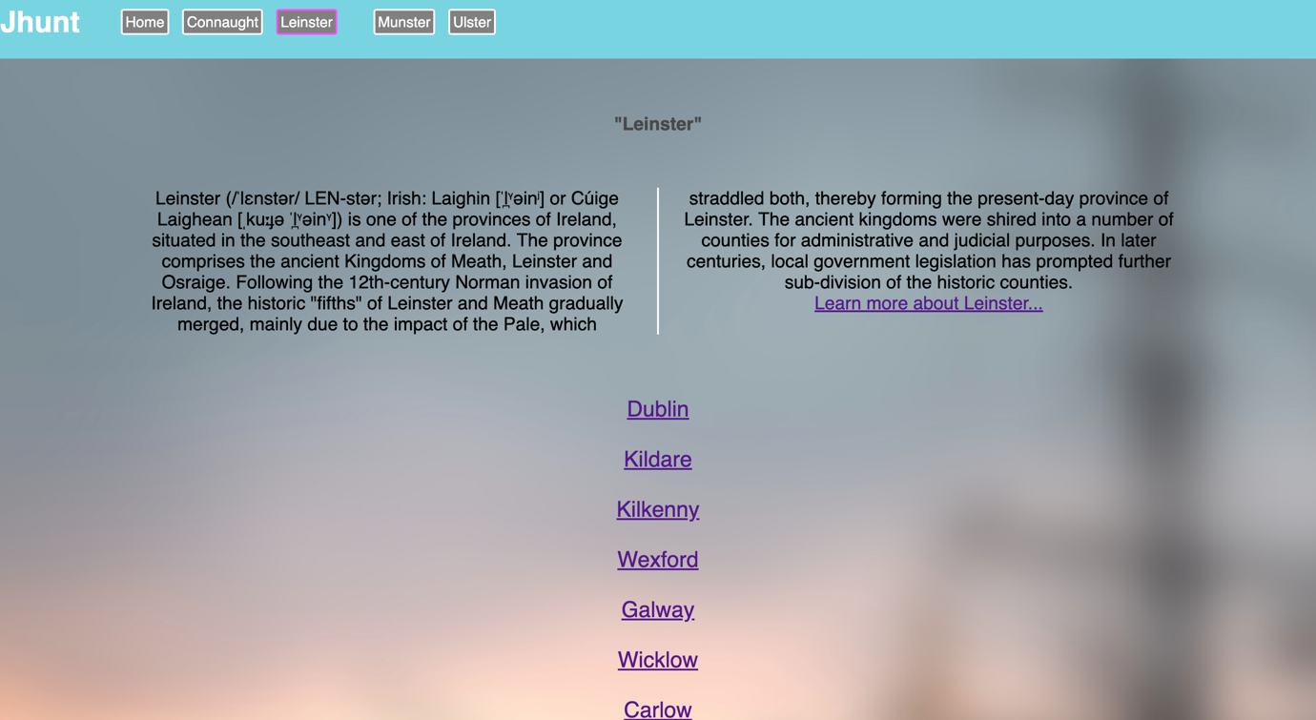

Page4(Munster page)

I put information about Munster with the link to Wikipedia, added background image, and links to counties of Munster.

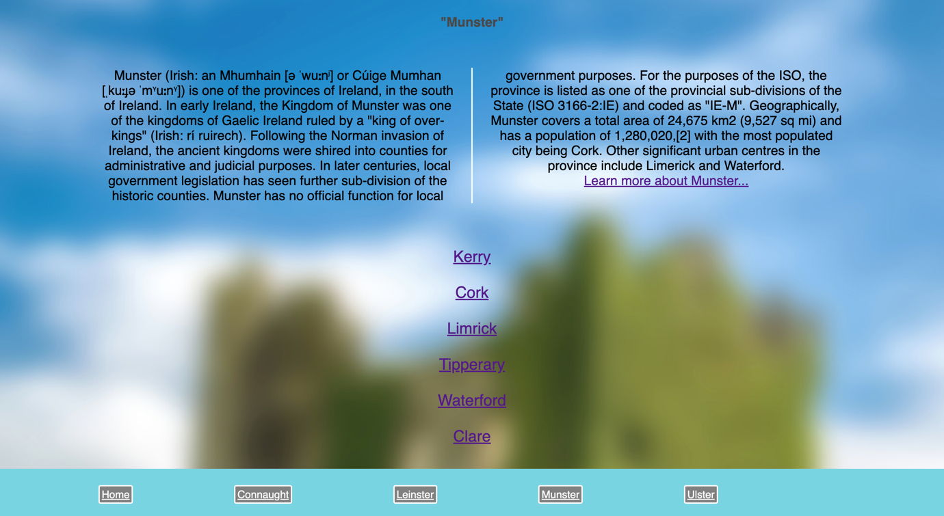

Page5(Ulster page)

I put information about Ulster with the link to Wikipedia, added background image, and links to counties of Ulster.

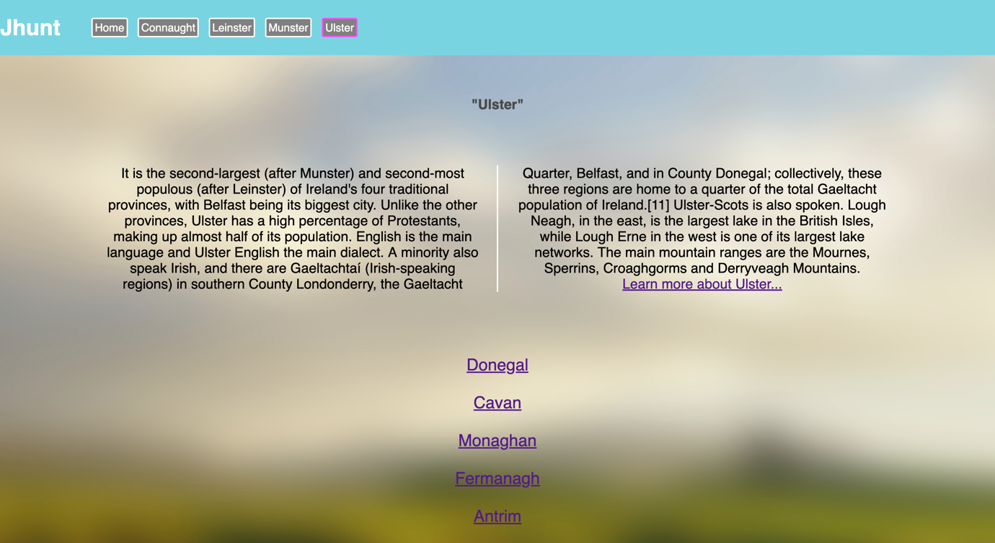

Page6(Job found page)

I put jobs information with apply button to apply form page, floated man picture beside the text.

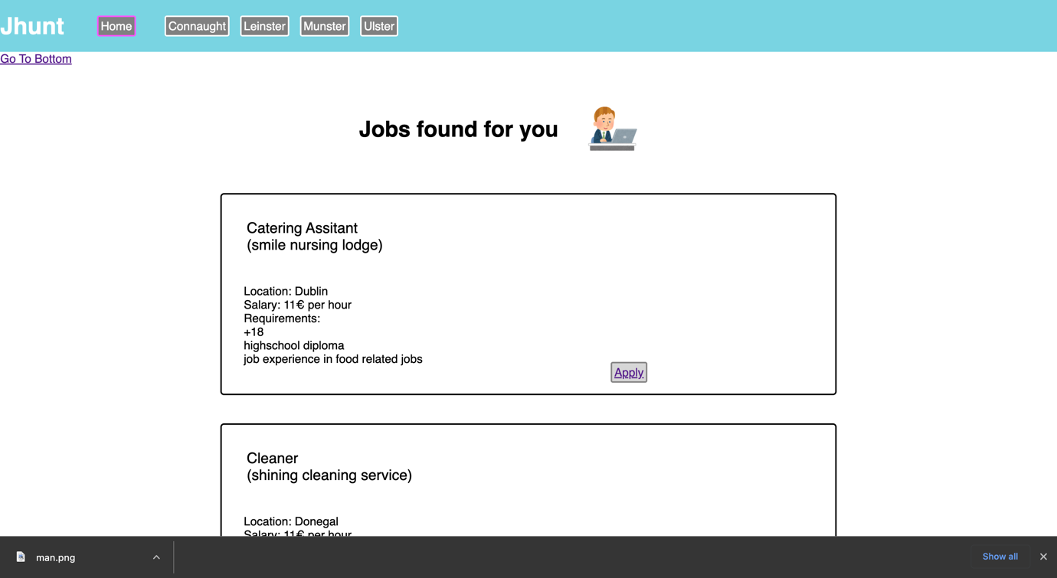

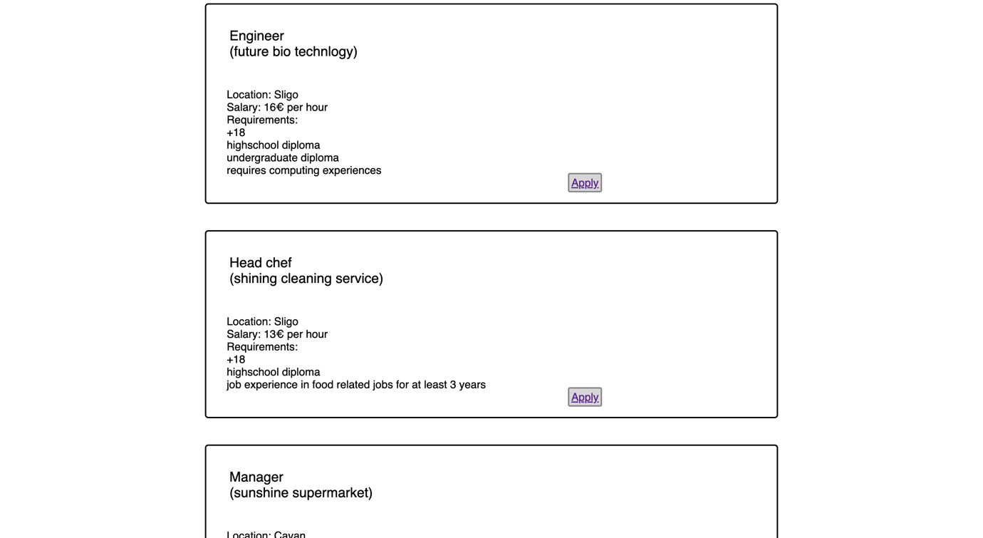

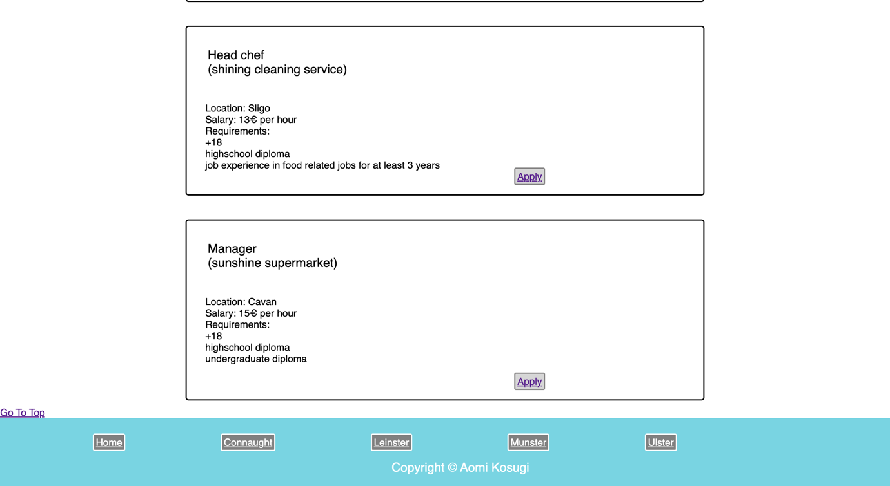

Page7(apply from page)

Added apply from page to apply for jobs.

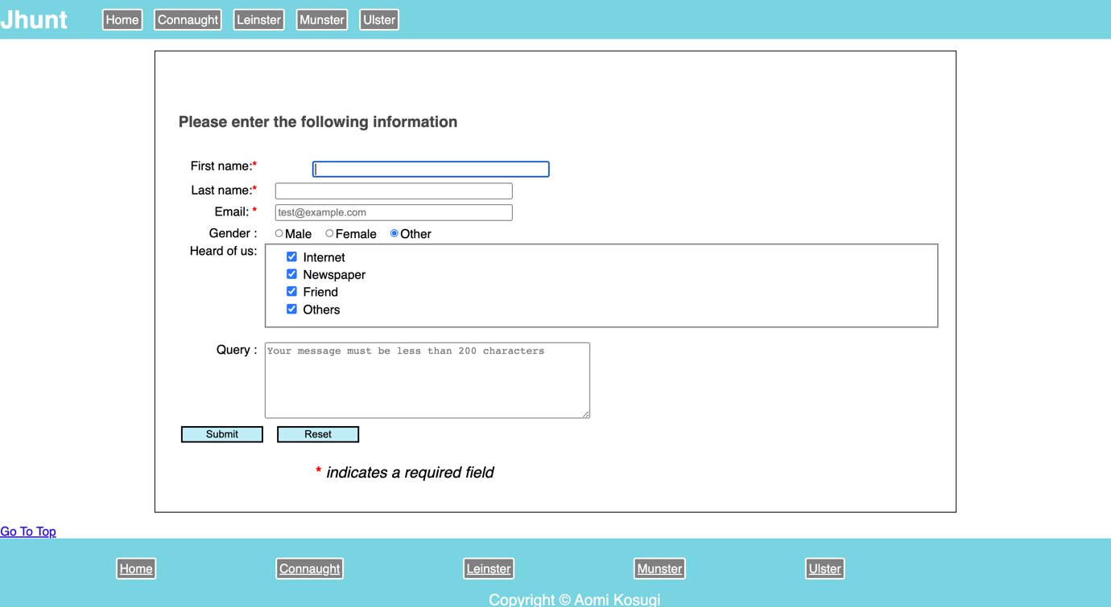

Sources of information

<https://unsplash.com/photos/Gx_OSk5LpVY>

<https://unsplash.com/photos/Hjgg_b-nTOw>

<https://unsplash.com/photos/8l-AK3QYFLE>

<https://unsplash.com/s/photos/donegal>

<https://www.youtube.com/watch?v=X3oNpIXR4TE&feature=emb_title&ab_channel=NameExplain>

https://www.irasutoya.com/2016/11/blog-post_495.html

**Website Project Check List**

|  |
| --- |
| **\*\*\* GitHub URL Progress upload of web site navigation and 3 pages – Week9** |
| **Project Report, Upload zipped folders all website files with report, (place college project on front page, no personal information to be included and public domain images and reference text and videos)** |
| **Minimum of 4 HTML Page Website** |
| **HTML5 standards and recommended page layout structure** (header,main,aside,article,section,footer) |
| **Include Meta data – description, keywords, title - Maximise SEO** |
| **Include font family for body of page** |
| **Appropriate use of External Style Sheet – Recommended CSS** |
| **Appropriate Example using Internal Styling on HTML page** (an example) |
| **Appropriate Example using of inline Styling** (an example) |
| **Home page content aligned to each other and visually attractive** |
| **Consistency of design on all pages above fold, aligned, use of fonts, colour etc.** |
| **Appropriate use of Headings (h1, h2, h3, h4)** |
| **Appropriate use of Colours, easy to read and complimentary colours** |
| **Include an article , section and aside sections** |
| **Clear, consistent and align content on page (reference all sources)** |
| **Include public domain images (**with at least on image floated with text**)** |
| **Use of background image** |
| **Include table of data/information** |
| **Include lists ordered and unordered (**different shaped bullet points**)** |
| **Include favicon and logo on your website** |
| **Include a contact form Display values entered in form and include red * beside required/mandatory input fields** |
| **Verify data collected on contact form, using get and data attached to URL** (Use the method get to display values entered on form will be appended to url and passed to server <form <action="http://foo.com" method="get">) |
| **Include google maps** |
| **Include columns using css that displays 2 or 3 columns on a page** |
| **Footer information include html entity Copyright© year and footer navigation menu** |
| **Include Internal Links and External Links** |
| **All pages should be up to 70% responsive** |
| **Include suitable video** |
| **Include Appropriate use of CSS Class and Id selectors** |
| **Appropriate use content layout using margins, paddings and borders (<br**> only used to split text on separate line eg address) |
| **Additional Features _Opacity, Fontawsome_________________** |
| **W3C HTML & CSS Validator results (in report)** <https://validator.w3.org/nu/#file> |
| **Report include Proposal, Declaration of your own work , URL to Github, Rough Sketch of layout design, brief descriptions of the web site its pages and sources for information and Validator results** |
| **Website appearance, design and Content** [**https://webdesignledger.com/10-signs-of-a-user-focused-design/**](https://webdesignledger.com/10-signs-of-a-user-focused-design/)[**https://webdesignledger.com/20-dos-and-donts-of-effective-web-design/**](https://webdesignledger.com/20-dos-and-donts-of-effective-web-design/) |

**Validation Results**

Index.html

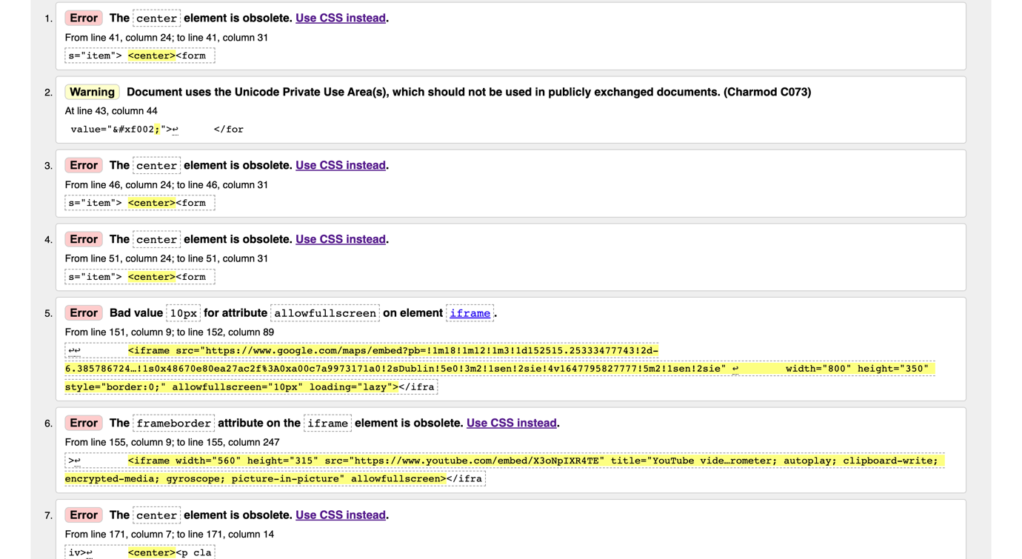

Connacht.html

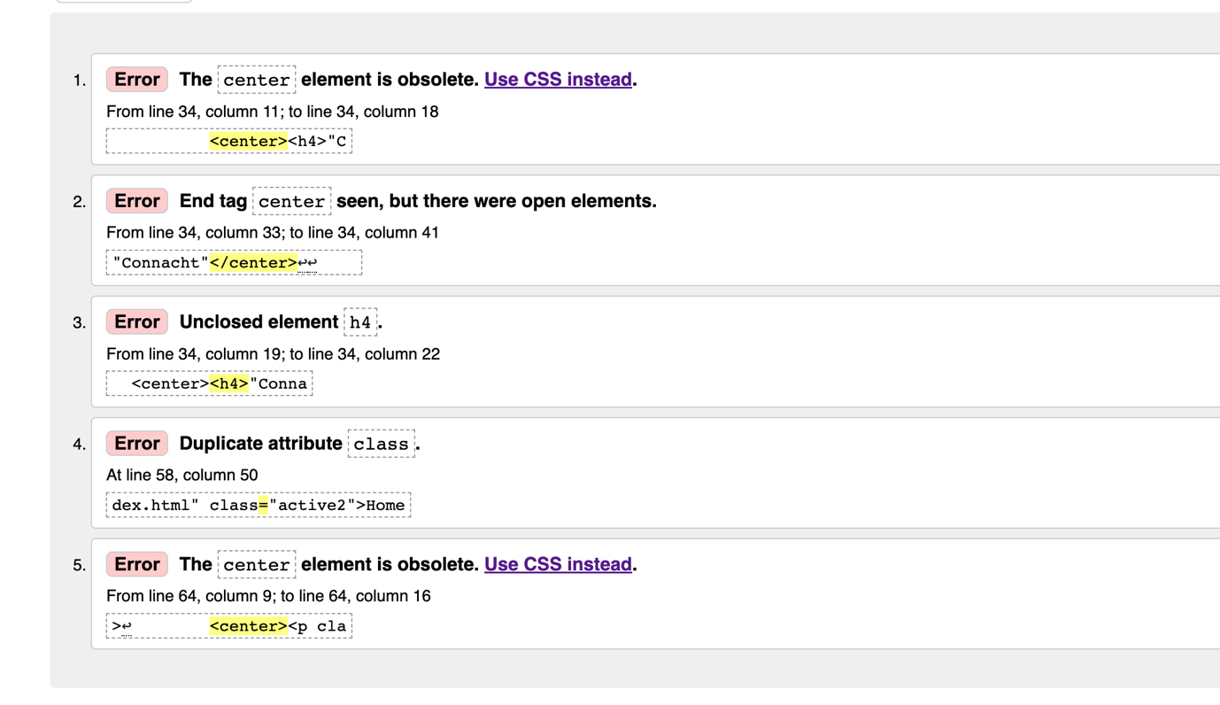

Leinster.html

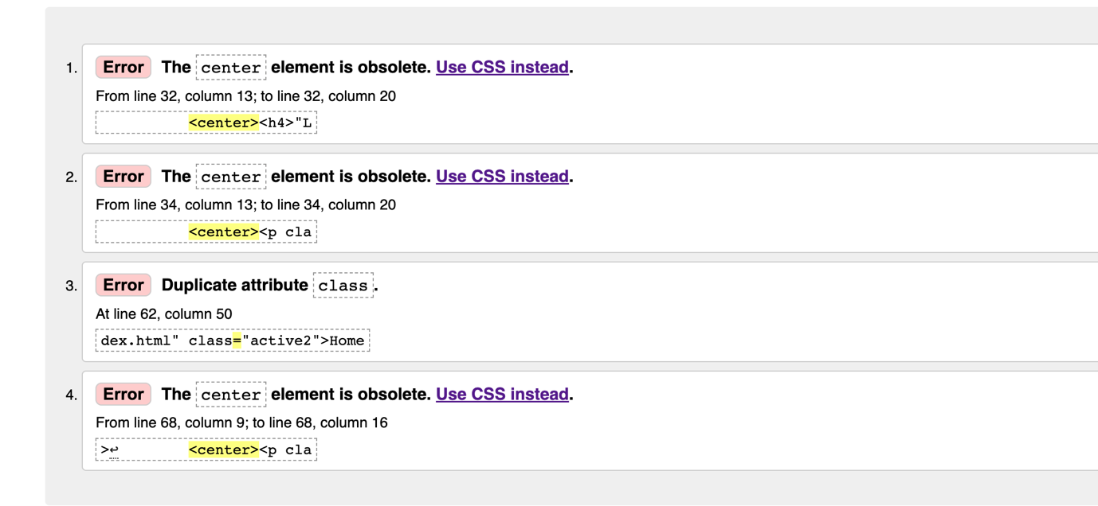

Munster.html

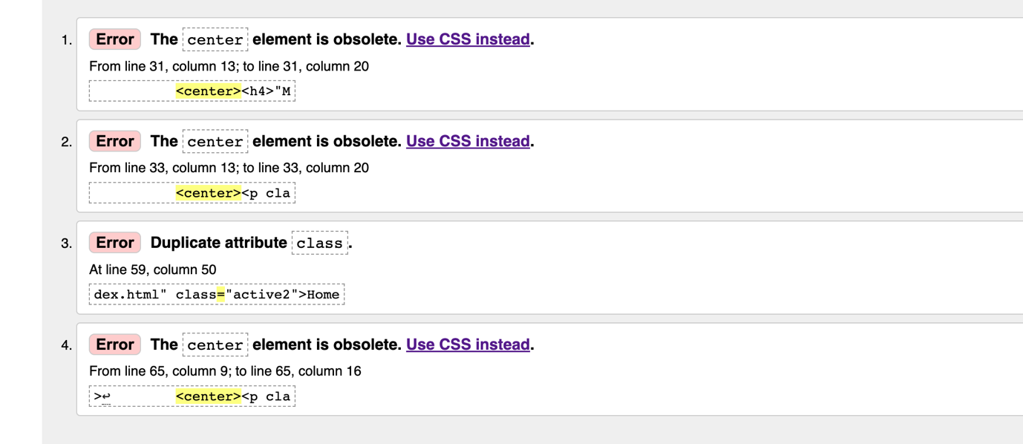

Ulster.html

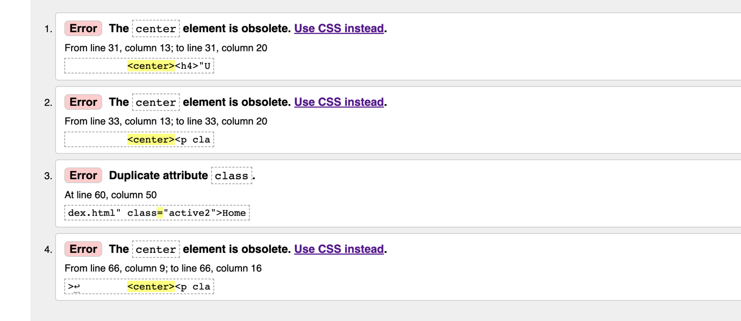

Jobs.html

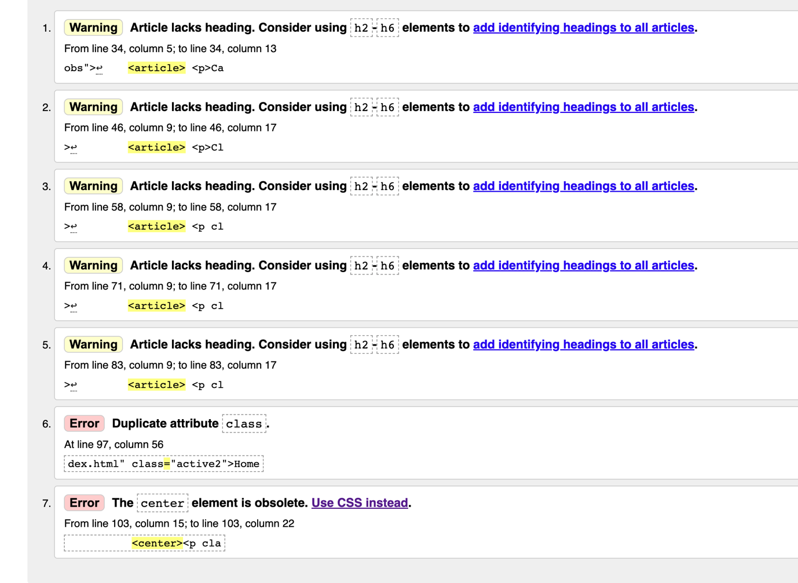

Applyform.html

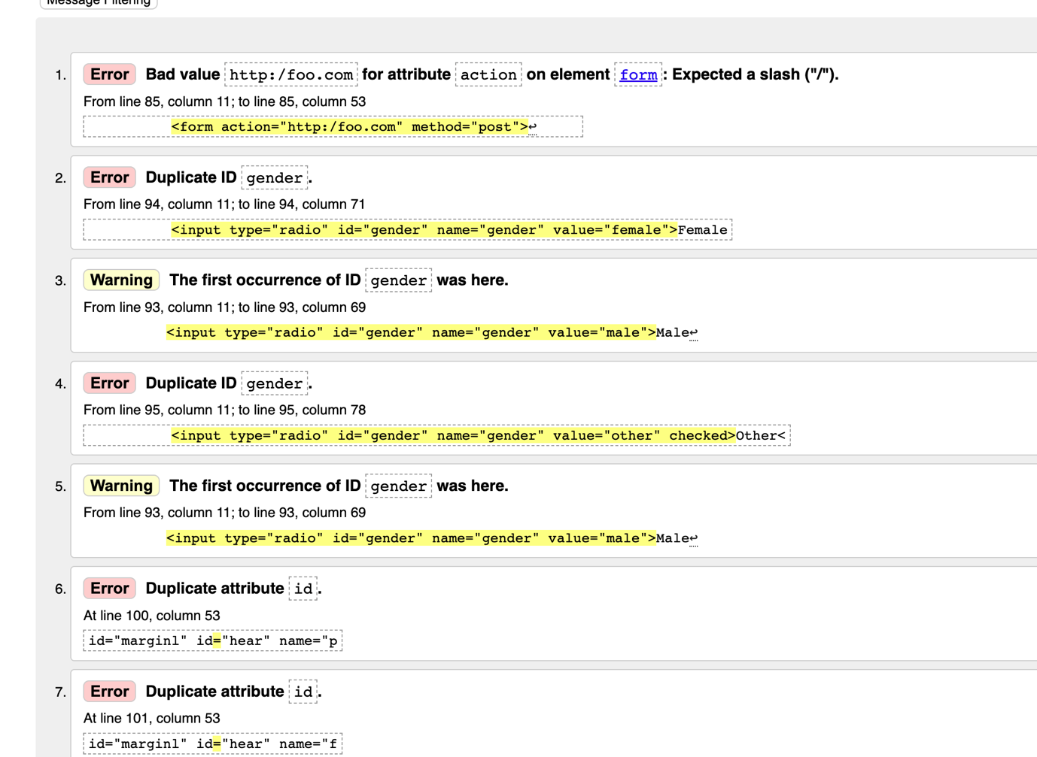

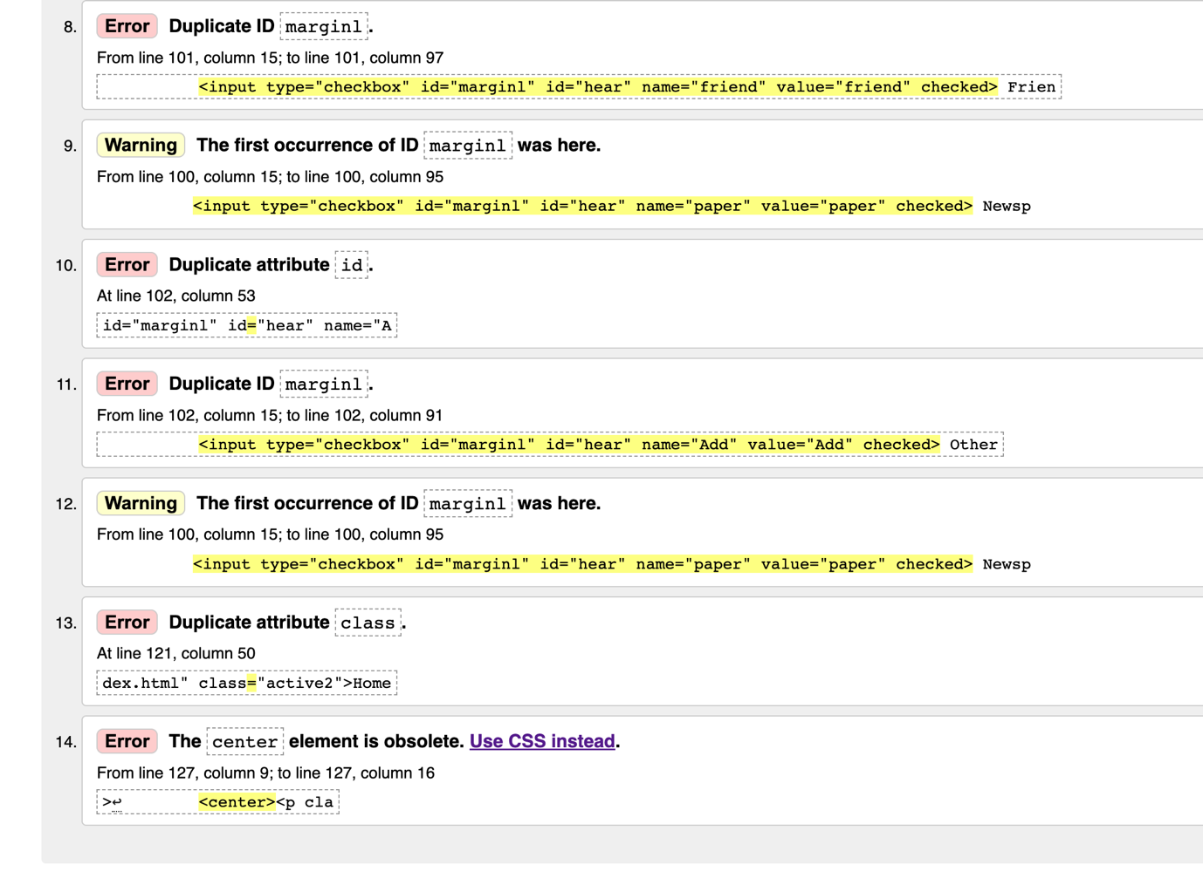

**Declaration Form**

I the undersigned declare that the project material, which I now submit, is my own work. This material or project has not previously been submitted for any other assignment. Any assistance received by way of borrowing from previous work, or the work of others has been cited and acknowledged within the work. I make this declaration in the knowledge that a breach of the rules pertaining to project submission may carry serious consequences. We are aware that the project will not be accepted unless this form has been handed in along with the project.

Website Topic__Jhunt website (job searching website)__________________________________

Student name:___Aomi Kosugi_________________________________

Student number:_S00217075__________________________________

Date:____13/04/2022________________________________________